 Lab Report 01

An introduction to Arduino and Interfacing of Gas Sensor using Arduino and showing the Sensor Data in OLED Display.

**Submitted to,**

Mr. Md. Abid Hossain

Lecturer, Dept. of CSE

**Submitted by,**

Sahadat Islam Evan

ID: 011 203 030

Section: B

Course Code: CSE 4326

Date

13/02/2024

Table of Contents

Objective: 3

Components used: 3

Hardware: 3

Software: 3

Procedure: 3

**i.** **Arduino Board Setup:** 3

**ii.** **Interfacing OLED display with the gas sensor circuit:** 4

Problems and considerations: 7

Conclusion: 7

# Objective:

The primary objective of this experiment is to learn the software and hardware fundamentals of Arduino and the process of interfacing a Gas Sensor using Arduino. Additionally, gain hands-on experience in displaying the sensor data on an OLED display.

# Components used:

## Hardware:

1. Arduino Uno board
2. LED
3. MQ-2 Gas Sensor
4. OLED Display (SSD1306)
5. Breadboard
6. Jumper wires
7. 10k ohm Resistor

## Software:

1) Arduino IDE

# Procedure:

## i.Arduino Board Setup:

Place the Arduino board on the breadboard, ensuring a stable connection, and connect the necessary wires to establish a reliable power supply.

## ii.Interfacing OLED display with the gas sensor circuit:

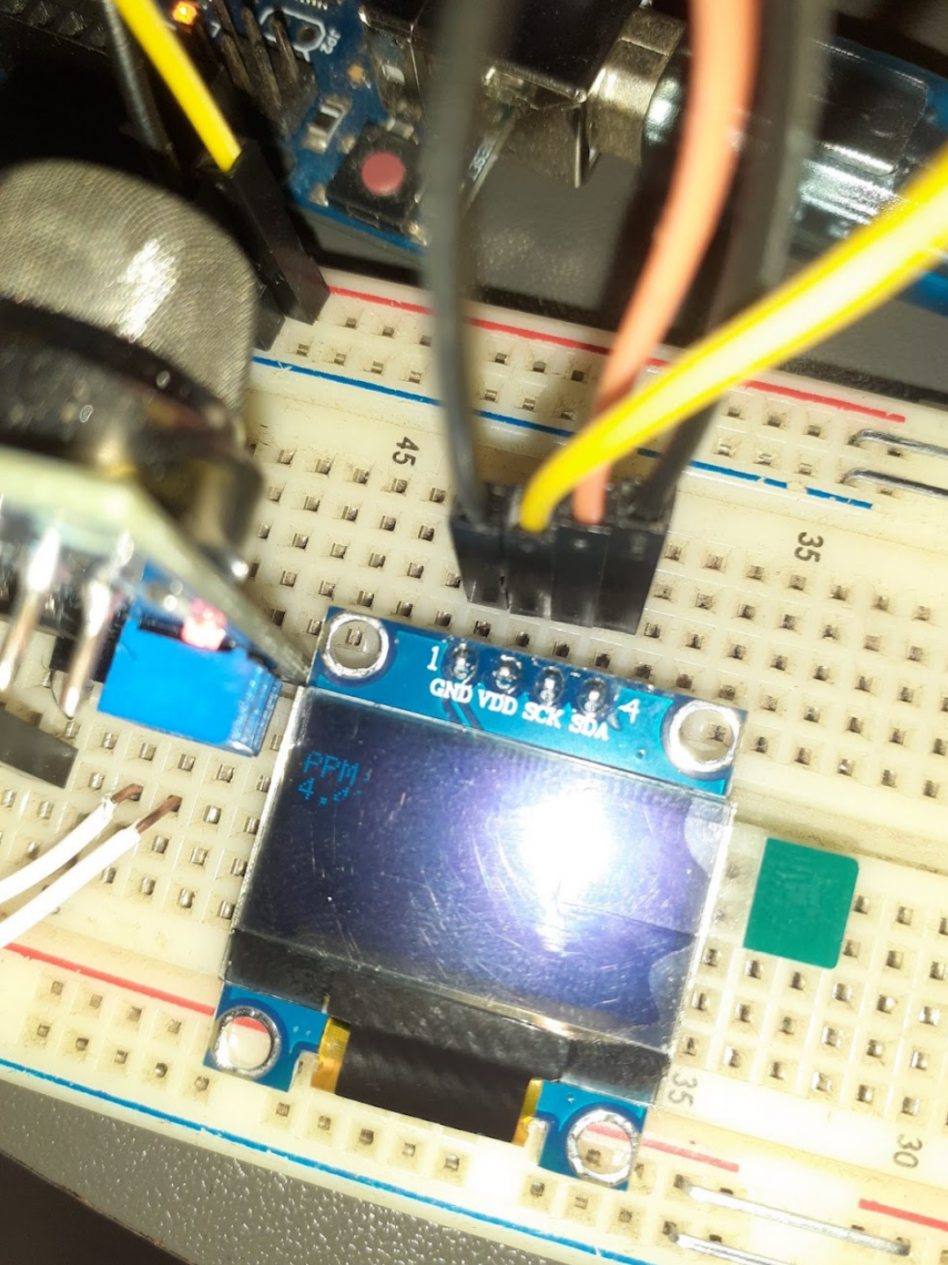

**Fig 4: Showing calculated ppm result by the Gas Sensor on OLED display**

**Code:**

#include <Wire.h>

#include <Adafruit_GFX.h>

#include <Adafruit_SSD1306.h>

#define OLED_RESET -1 // Reset pin # (or -1 if sharing Arduino reset pin)

#define SCREEN_ADDRESS 0x3C //< See datasheet for Address; 0x3D for 128x64, 0x3C for 128x32

Adafruit_SSD1306 display(128, 64, &Wire, OLED_RESET); const int sensorPin = A0;

unsigned long prevMil = 0; const long interval = 1000;

// Define the load resistance value (in ohms) used in the circuit

#define RL 10 //Load resistance

#define m -0.263 //Calculated Slope

#define b 0.42 //Calculated intercept

#define Ro 20 // Resistance on fresh air

void setup() {

Serial.begin(9600);

Serial.println("MQ2 warming up!"); if (!display.begin(SSD1306_SWITCHCAPVCC, SCREEN_ADDRESS)) { Serial.println(F("SSD1306 allocation failed"));

} display.clearDisplay(); display.setTextColor(WHITE); display.setTextSize(1); display.display(); delay(20000); // allow the MQ2 to warm up

}

void loop() { unsigned long currentMil = millis();

if(currentMil - prevMil >= interval){ float VRL; //Voltage drop across the MQ sensor float Rs; //Sensor resistance at gas concentration float ratio; //Define variable for ratio float sensorValue = analogRead(sensorPin);

Serial.println(sensorValue);

VRL = sensorValue * (5.0/1023.0); //Measure the voltage drop and convert to 0-5V

Rs = ((5.0*RL)/VRL)-RL; //Use formula to get Rs value ratio = Rs/Ro; // find ratio Rs/Ro

float ppm = pow(10, ((log10(ratio)-b)/m)); //use formula to calculate

ppm display.clearDisplay(); display.setCursor(0, 12); display.println("PPM: "); display.println(ppm); display.display();

prevMil = currentMil;

}

}

# Problems and considerations:

1. OLED display was bit hard to configure. But after following guideline it worked.
2. In the code section I faced some difficulties too.
3. It took time to install the libraries .

# Conclusion:

The experiment that was given to generate the lab report was essential to know the basic interfacing of Arduino with sensor and display. After completing the whole experiment all of the objective was fulfilled and everything